Public Community Discovery

Users  - Primary  - Community manager  - Secondary | Phase 1
Intended Outcome
- Organizers create their community profile as they want their communities to become visible to outsiders and prospective members.
Links
- Figma
- …
- …
- …
- …

Introduction
One of the community organizers we invited to try Kolavo ended up leaving after registration and saying that he wanted to see communities in it before creating his own. This seems he did not have the motivation of creating his community profile because he did not know what it would look like. Therefore, we want to motivate community organizers to create their community profiles by making community lists visible to the public.

Product Requirement
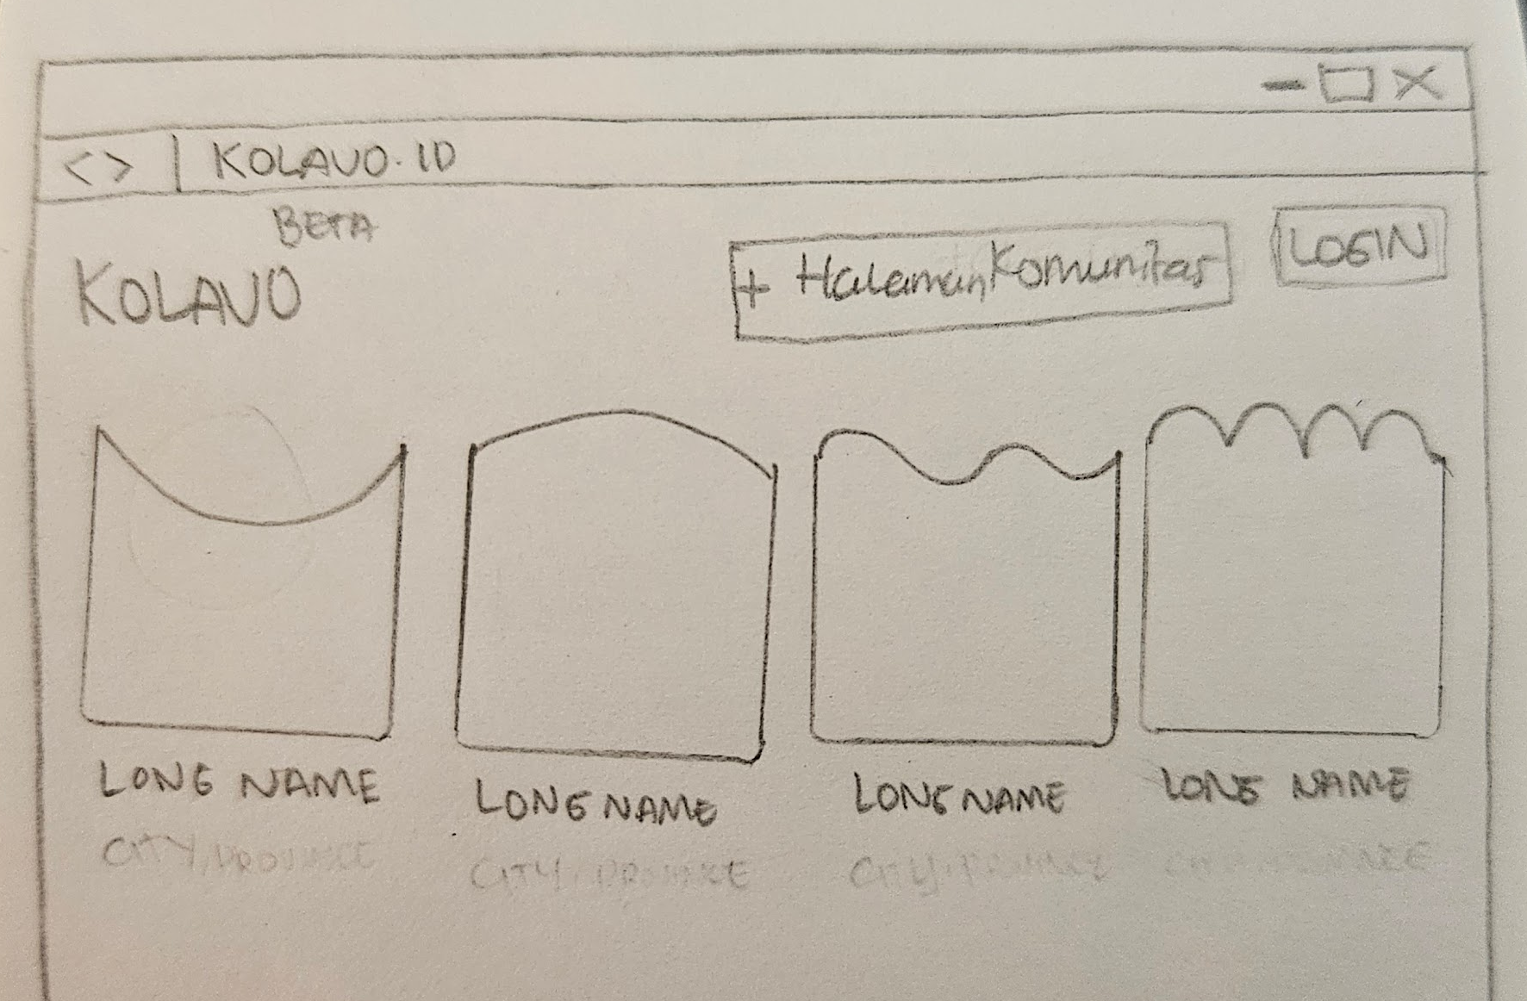
No. | User story | Scope | Acceptance Criteria
1 | As community organizers, I want to see what listed communities look like | Community directory visible to non registered users | - All visitors who access Kolavo.id directed to homepage contains community directory
1 |  | Show fixed first-page display limit in home page | - Each community position should not be fixed. It should be dependent on how much info within each community.
1 |  | Differentiables community identities | Showing:  - Logo  - Long name (5-10 words)
2 | As community organizers, I want to see further information of listed communities | When a community clicked, opens community page | - Community page opened has to be the same with community linked
3 | As community organizers, I want to create my own community profile | Create community button | - Easy to find  - If not logged in, redirect to login process, then to create community form page  - If logged in, direct to create community form page
4 | As community organizers, I want to access it on mobile phone when needed | Mobile responsive | - Looking tidy when accessing using mobile phone  - Have accessible menu
5 | As community organizers, I want to easily know where to login | Login button | - Easy to find  - When clicked, direct to login page

Design Requirement

Kolavo Logo
Design Intent | Show Kolavo brand clearly
Content / Copy | Use Kolavo logo.
Visual Requirement | Kolavo logo appears at the top left of the homepage header.
Interaction Behavior | Static element. No hover or interaction required.
Acceptance Criteria | Kolavo logo is displayed clearly in the header and remains readable on desktop and mobile.

Tambah Halaman Komunitas Button
Design Intent | The primary CTA should be eye-catching, represent Kolavo, and encourage community organizers to create their page.
Content / Copy | + Halaman Komunitas
Visual Requirement | - Font Family: Poppins, sans-serif  - Font Weight: 500 (Medium)  - Font Size: 16px (base/default)  - Line Height: 1.5  - Text Color: White (#FFFFFF)  - Background Color: #FF6B35 (Orange Kolavo)  - Padding: 24px horizontal, 12px vertical  - Border Radius: 8px (rounded-lg)  - Hover Effect: Box shadow 2px 2px 8px rgba(0, 0, 0, 0.15)
Interaction Behavior | - On mouse hover, button color stays the same.  - Add subtle shadow on the right, left, and bottom side of the button.  - No layout shift.
Acceptance Criteria | The button appears in Kolavo orange with white text, uses + Halaman Komunitas as copy, remains visually prominent in the header, and gains subtle shadow on hover without changing its base color.

Homepage Header
Design Intent | The homepage should feel conversational, inviting, and not too formal.
Content / Copy | Mana Komunitasmu?
Visual Requirement | - Font Family: Poppins, sans-serif  - Font Weight: 600 (Semi-Bold)  - Font Size: 32px  - Line Height: 38px  - Letter Spacing: -1px  - Text Color: #342621 (Dark Brown)  - Text Align: Center
Interaction Behavior | Static text. No hover or motion required.
Acceptance Criteria | The header copy Mana Komunitasmu? appears centered above the community list using H1 hierarchy, black color, 32px size, 38px line height, letter spacing -1, and weight 700.

Community Logo
Design Intent | Each community should feel visually distinct through its own logo identity.
Content / Copy | No copy.
Visual Requirement | - Position logo centered above the long name.  - If the uploaded logo has a transparent background, preserve the original shape of the logo rather than forcing it into a solid image box.  - If no logo uploaded, use the first initial letter with background of color theme chosen.
Interaction Behavior | - Static by default.  - No hover behavior required unless the whole card is hovered.
Acceptance Criteria | - Each community card shows the logo centered above the long name.  - Transparent-background logos preserve their original visible shape.  - If no logo exists, system fallback behavior should be defined elsewhere.

Community Long Name
Design Intent | Community names should look consistent by default, while still becoming more distinctive during interaction.
Content / Copy | Use each community’s long name.
Visual Requirement | - Font Family: Poppins, sans-serif  - Font Weight: 400 (Regular)  - Font Size: 16px (default from h3)  - Line Height: 1.5  - Text Color:  - Normal: #342621 (Dark Brown)  - Hover: Theme color dari komunitas (berbeda-beda sesuai branding komunitas)  - Text Align: Center  - Transition: Color transition 200ms
Interaction Behavior | - On mouse hover, the long name changes to the selected community theme color.  - No movement or layout shift.
Acceptance Criteria | Each community long name appears bold and black by default, is center aligned under the logo, and changes to the selected community theme color on hover.

Community Card
Design Intent | Community cards should feel light and minimal by default, while still showing interactivity on hover.
Content / Copy | - No fixed copy.  - Each card contains community-specific logo and long name.
Visual Requirement | - Very thin transparent Kolavo blue border.  - Show 4 community cards in one row on desktop.  - Show unlimited communities in one page.
Interaction Behavior | - On mouse hover, add a very thin transparent Kolavo blue border and a subtle shadow on the right, left, and bottom side of the card.  - Keep layout stable.
Acceptance Criteria | Community cards appear borderless by default, display in a 4-column layout on desktop, show up to 40 communities per page, and gain a thin Kolavo blue border plus subtle shadow on hover without shifting layout.

Login Button
Design Intent | The Login button should remain visible and accessible, but visually secondary to the + Halaman Komunitas CTA.
Content / Copy | Login
Visual Requirement | - Font Family: Poppins, sans-serif  - Font Weight: 500 (Medium)  - Font Size: 16px (base/default)  - Line Height: 1.5  - Text Color: White (#FFFFFF)  - Background Color: #5D9CEC (Blue Kolavo)  - Padding: 24px horizontal, 12px vertical  - Border Radius: 8px (rounded-lg)  - Hover Effect: Box shadow 2px 2px 8px rgba(0, 0, 0, 0.15)
Interaction Behavior | - On mouse hover, button color stays the same.  - Add subtle shadows on the right, left, and bottom side of the button.  - No layout shift.
Acceptance Criteria | The Login button uses Kolavo blue with white text, displays Login as copy, remains visually secondary to the orange CTA, and gains subtle shadow on hover without changing its base color.

Bottom Navigation Bar
Design Intent | The homepage should remain easy and comfortable to access on mobile without losing the main actions.
Content / Copy | Showing three menus:  - Community List: Komunitas  - Create community page: Buat  - Login: Akun
Visual Requirement | - Color for icon and text:  - Active: #342621 (dark brown)  - Inactive: #9ca3af (grey blue)  - If logged in, text and icon Akun change to:  - Profile picture 40x40px  - Active state: border 2px solid #342621  - Background: #5D9CEC (Kolavo blue) and Avatar: emoji 👤 when no profile picture uploaded
Interaction Behavior | - Komunitas opens community list page  - Buat opens community page creation form  - Akun opens login page if not logged in, if logged in opens user profile
Acceptance Criteria | - A fixed bottom navigation bar is displayed on mobile homepage.  - The bottom navigation bar shows three menu items:  - Komunitas  - Buat  - Akun  - Each menu item shows an icon and text label.  - The active menu item uses color #342621.  - Inactive menu items use color #9ca3af.  - When user is not logged in, the Akun menu shows a user account icon and the label Akun.  - When user is logged in, the Akun menu shows the user’s profile picture instead of the default icon and label.  - Tapping Komunitas opens the community list page.  - Tapping Buat opens the community page creation form.  - Tapping Akun opens the login page when user is not logged in.  - Tapping Akun opens the user profile page when user is logged in.  - The page content includes enough bottom spacing so content is not covered by the fixed bottom navigation bar.

Engineering Requirement

Questions

